Name: M Madan Mohan
Sap id: 51834548
Batch: JAVA-1, lab 3.
PROJECT NAME: Restaurant Bill.
It is a program that computes the tax and tip on a restaurant bill. The program will ask the user to enter the cost of the meal. The tax should be 10.5 percent of the meal cost. The tip should be 20 percent of the total cost after adding tax. Display meal cost,total cost,tip amount, and total bill on screen.
PROGRAM:
import java.util.Scanner;
public class RestaurantBill {
public static void main( String [ ] args ) {
//Declare variables
Scanner scanner = new Scanner( System.in );
double mealCost;
double tax;
double totalCost;
double tip;
double totalBill;
System.out.println( "please enter the cost of the meal: " );
mealCost = scanner.nextDouble();
//Calculate the tax
tax = 0.105 * mealCost;
totalCost = mealCost + tax;
tip = 0.2 * totalCost;
totalBill = totalCost + tip;
System.out.println( "Cost of meal: $" + mealCost );
System.out.println( "Tax: $" + tax );
System.out.println( "Tip: " + tip );
System.out.println( "Total Bill: " + totalBill );
}
}

OUTPUT:

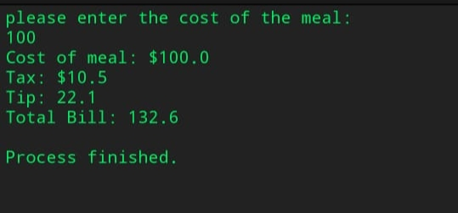

THANK YOU

